Name: Kavya Pagaria  
Course: Android App Development using Kotlin  
Registration number:21BHI10073  
VIT BHOPAL CAMPUS

Assignment 2- Dice Program

Output:

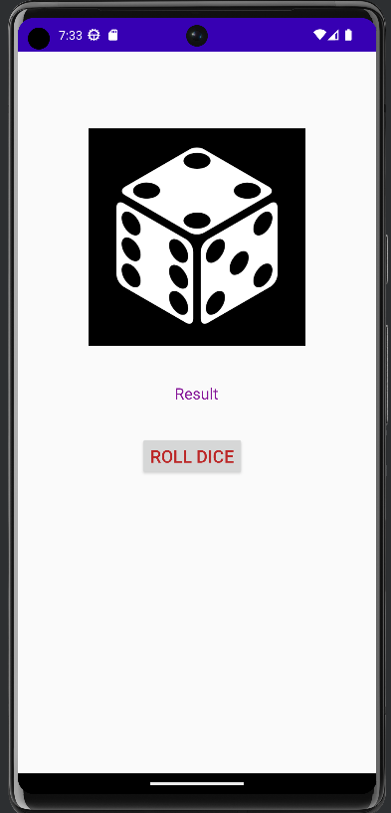 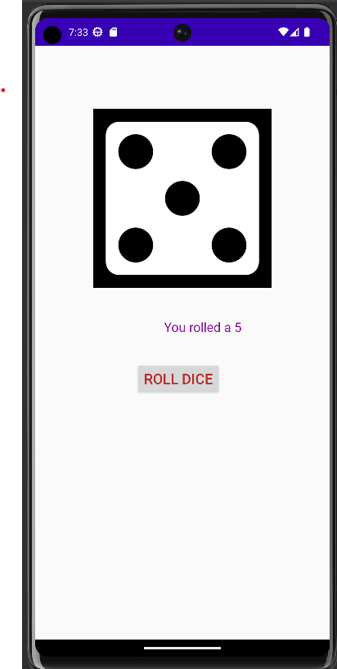 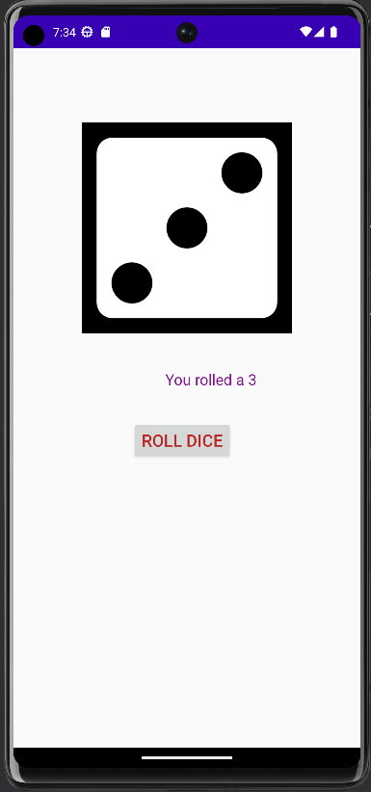

MainActivity.kt code

package com.example.diceprogram  
  
import android.os.Bundle  
import android.widget.Button  
import android.widget.ImageView  
import android.widget.TextView  
import androidx.activity.ComponentActivity  
import androidx.activity.compose.setContent  
import androidx.compose.foundation.layout.fillMaxSize  
import androidx.compose.material.MaterialTheme  
import androidx.compose.material.Surface  
import androidx.compose.material.Text  
import androidx.compose.runtime.Composable  
import androidx.compose.ui.Modifier  
import androidx.compose.ui.tooling.preview.Preview  
import com.example.diceprogram.ui.theme.DiceprogramTheme  
import java.util.*  
  
class MainActivity : ComponentActivity() {  
 private lateinit var tv: TextView  
 private lateinit var bt: Button  
 private lateinit var img: ImageView  
  
 override fun onCreate(savedInstanceState: Bundle?) {  
 super.onCreate(savedInstanceState)  
 setContentView(R.layout.*activity_main*)  
  
 tv=findViewById(R.id.*tv*)  
 bt=findViewById(R.id.*bt*)  
 img=findViewById(R.id.*img*)  
  
 bt.setOnClickListener **{** rollDice()  
 **}** }  
  
 private fun rollDice() {  
 val random = Random()  
 val randomNumber = random.nextInt(6) + 1  
 val resultText= "You rolled a $randomNumber"  
 tv.*text* = resultText  
  
 when (randomNumber) {  
 1 -> img.setImageResource(R.drawable.*dice1*)  
 2 -> img.setImageResource(R.drawable.*dice2*)  
 3 -> img.setImageResource(R.drawable.*dice3*)  
 4 -> img.setImageResource(R.drawable.*dice4*)  
 5 -> img.setImageResource(R.drawable.*dice5*)  
 6 -> img.setImageResource(R.drawable.*dice6*)  
 }  
  
 }  
}